

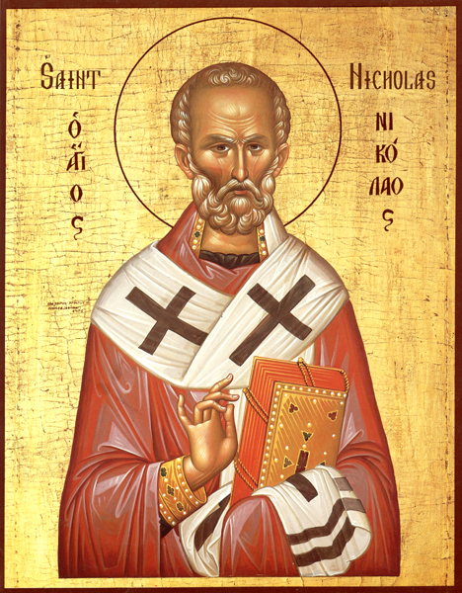

Services and Music

**December 2022**

**The Rev’d Preb. David Wright** *Rector*

**Callum Alger** *Director of Music*

**Charles Francis** *Assistant Director of Music*

**Elli-Mae McGlone** *Organ Scholar*

**St Peter’s Collegiate Church**, Lich Gates, Wolverhampton, WV1 1TY



01902 422 642

wolvescentralparish@hotmail.co.uk

**2 FRIDAY**

12.30 Said Eucharist

13.15 Lunchtime Live!

*Anthony Pinel (organ)*

**4 SUNDAY** THE SECOND SUNDAY OF ADVENT

11.15 Choral Eucharist

Advent Prose (v. 2) Hymns: 12, 5, 10, 408(i)

Messe in G-flat minor *de Lioncourt*

E’en so Lord Jesus *Manz*

Voluntary: Nun komm, der Heiden Heiland *Nicolas Wolleb*

18.30 Choral Evensong

Preces & Responses *plainsong*

Evening Service in F *Dyson* Psalm 11

Kindle a light *Fleming* Hymns: 490, 1(i), 388(i)

Voluntary: White Note Paraphrase *James MacMillan*

**7 WEDNESDAY**

17.15 Choral Evensong

Preces & Responses *plainsong*

The Durham Service *Chris Totney* Psalm 119: 33-40

Fum, fum, fum *trad. Catalan, arr. Llewellyn* Hymn 19(ii) [omit *]

**8 THURSDAY**

14.00 Wolverhampton University Carol Service

**9 FRIDAY**

12.30 Said Eucharist

13.15 Lunchtime Live!

*Emily Hopper (harp)*

**11 SUNDAY**THE THIRD SUNDAY OF ADVENT

11.15 Choral Eucharist

Advent Prose (v. 3) Hymns: 3(ii), 6, 443, 7

Communion Service in D *Leighton*

How beautiful upon the mountains *Stainer*

Voluntary: Postlude in D minor *Stanford*

18.30 Choral Evensong

Preces & Responses *Smith*

Fourth Evening Service *Batten* Psalm 12

This is the record of John *Gibbons* Hymns: CP 220(ii), 1(i), 415 (t. 346)

Voluntary: Nun komm, der Heiden Heiland, BWV 659 *J.S. Bach*

**14 WEDNESDAY**

17.15 Choral Evensong

Preces & Responses *plainsong*

Evening Service in E-flat *Bairstow* Psalm 82

Jesus Christ the apple tree *Holman* Hymn 18

**15 THURSDAY**

14.00 Good Shepherd Ministry

**16 FRIDAY**

12.30 Said Eucharist

13.15 Lunchtime Live!

*Charles Francis (organ)*

**18 SUNDAY**THE FOURTH SUNDAY OF ADVENT

11.15 Choral Eucharist

Advent Prose (v. 4) Hymns: 19, 57, 185, 188

Messe cum jubilo *Duruflé*

Ave maris stella *Grieg*

Voluntary: Fugue (Carillon de le Cathédrale de Soissons), Op. 12 *Duruflé*

18.30 Evening Prayer

**19 MONDAY**

18.30 Festival of Nine Lessons & Carols

Adam lay ybounden *Ledger*

In the bleak midwinter *Mack Wilberg*

The holly and the ivy *June Nixon*

Hymn to the Virgin *Britten*

All bells in paradise *John Rutter*

O magnum mysterium *Lauridsen*

Voluntary: Carillon de Westminster, Op. 54 *Vierne*

**22 THURSDAY**

19.00 Nova, Nova!

*A candlelit concert of music and readings telling the good news of the birth of Jesus Christ.*

*Tickets £10 (U18 FREE) available via Trybooking, or using the QR code on the inside cover.*

**24 SATURDAY** CHRISTMAS EVE

16.00 Nativity Service

23.30 Midnight Mass

Mass in G *Schubert* Hymns: 34, 32 (omit *), 30, 26 (omit *)

In the bleak midwinter *Darke*

Stille nacht *Grüber*

Voluntary: Toccata (*from* Symphony 5, Op. 42) *Widor*

**25 SUNDAY**CHRISTMAS DAY

11.15 Choral Eucharist

Communion Service in F *Sumsion* Hymns: 33 (omit *), 42, 30, 26 (omit *)

Nativity Carol *John Rutter*

Voluntary: In dulci jubilo, BWV 729 *J.S. Bach*

**LA NATIVITÉ DU SEIGNEUR**

**Wednesday, 1 February, 2023 / 7pm**

A sequence of readings and music with Messiaen’s *La Nativité du Seigneur* as the centrepiece, performed by our Director of Music, Assistant Director of Music, and Organ Scholar.

**NOVA, NOVA!**

**Thursday, 22 December, 2022 / 7pm**

The Choirs of St Peter’s Collegiate Church, Wolverhampton present a   
candlelit concert of music and readings telling the good news of the birth of Jesus Christ.

Tickets £10 / U18 FREE available via Trybooking (QR code below)



**JOINING THE CHOIR**

The Director of Music is always pleased to hear from new potential choristers, particularly boys (aged 7+) and girls (aged 8+).

For further information, or to express an interest, please email wolvescentralparish@hotmail.co.uk, or call 01902 422 642.

**Keep in touch** with St Peter’s Church at...

@choirofstpeters

@stpeterschoirs

@StPetersChurchWolverhampton or @stpeterschoirs